**FORMAN CHRISTIAN COLLEGE (A CHARTERED UNIVERSITY)**



**Computer Organization and Assembly Language – COMP 300 B**

**Spring 21**

**Lab - 01**

**Muhammad Sameed Gilani - 231488347**

**You should attach the lab / assignment handout as second page of this report.**

**From third page onwards following headings should be included:**

* **Introduction**
  + **Should carry information of all major library functions.**
* **Your logic / algorithm in simple English. Bullet points are appreciated.**
* **Your code**
* **Screen shots of at least three outputs of your code with appropriate inputs.**
* **References**

**INTRODUCTION:**

I used AND, OR, NOT gates and 4 input and 4 output pins to form a basic combinational circuit.

**LOGIC:**

* As there were 4 inputs, the truth table would have 24 = 16 rows.
* Then I filled the truth table by calculating the 2s complement of each 4bit input.
* Once I had the outputs, I wrote down each output column - w, x, y and z, in SOP form.
* After which I used kmaps to simplify the 4 equations.
* Once I had the simplified Boolean equations, I simply made the circuit for each output. Using AND, OR and NOT gates.
* Each circuit gave 1bit, of the 4bit output, corresponding to the 2s complement of the input.

**SAMPLE OUTPUTS:**

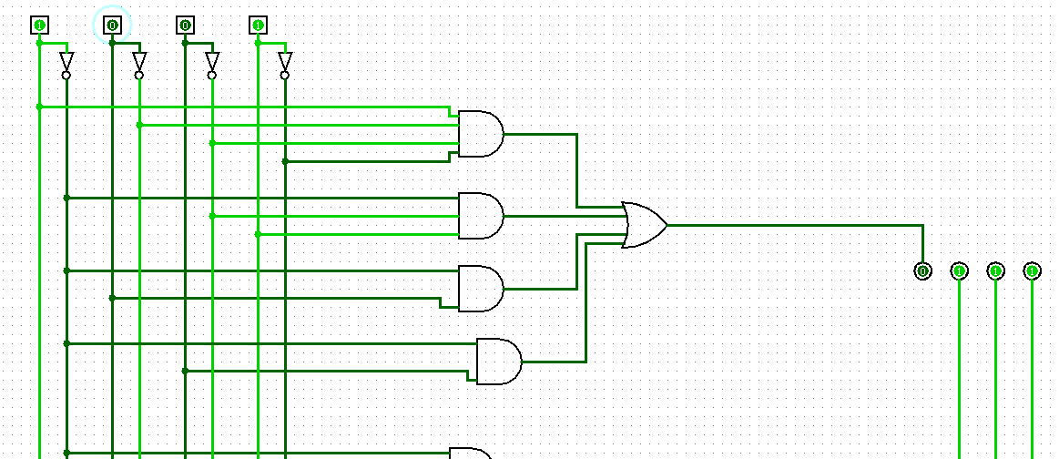1001 🡪 0111

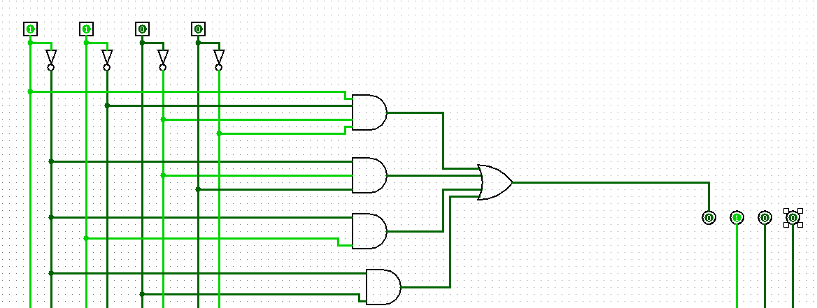1100 🡪 0100

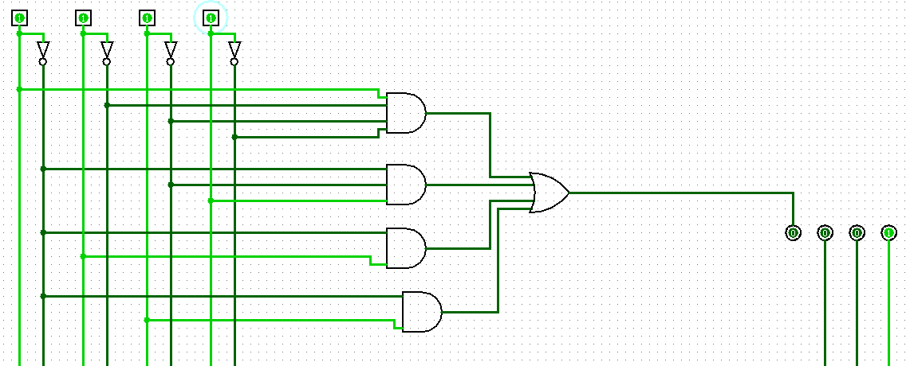1111 🡪 0001